**DAY -9 ESTIMATE  (1-2 hours)**

**TASK 01:**

* Create an EC2 Instance:
  + AMI Linux
  + t2.micro - Instance Type
  + Enable Termination Protection
  + Security Group
    - Open it for:
      * SSH
      * HTTP
      * HTTPS
  + Tag:
    - Key
      * Name
    - Value
      * ProdInstance
  + Key Pair

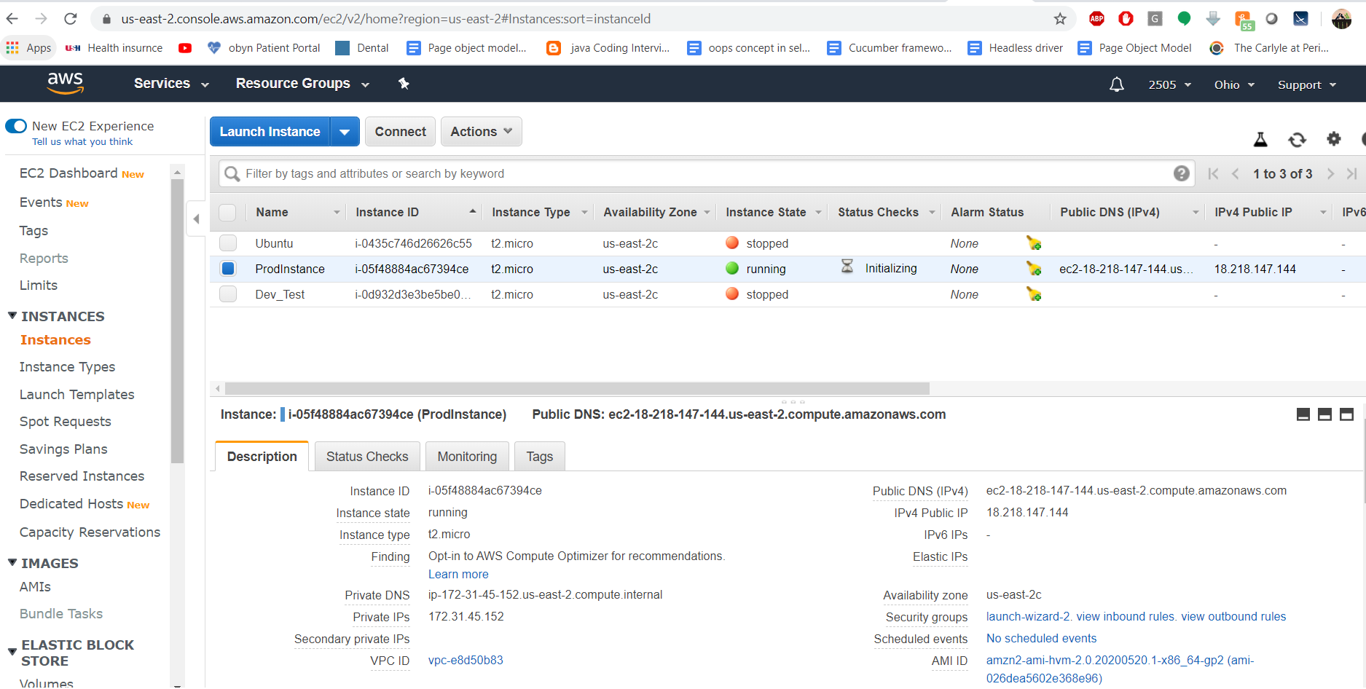

**TASK 02:**

* Connect with an instance using SSH on Mac/Linux and Windows users can use Putty

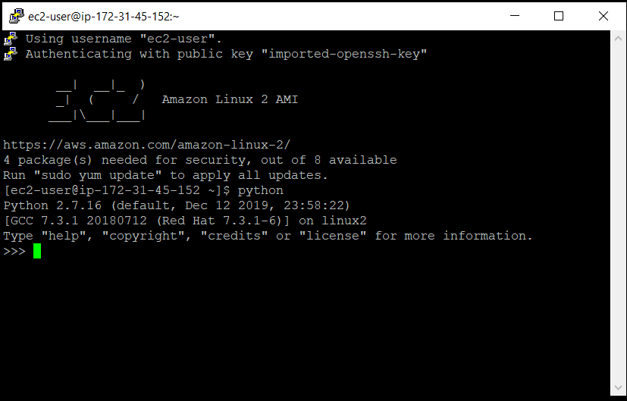

**TASK 03:**

* Install Apache Web Server

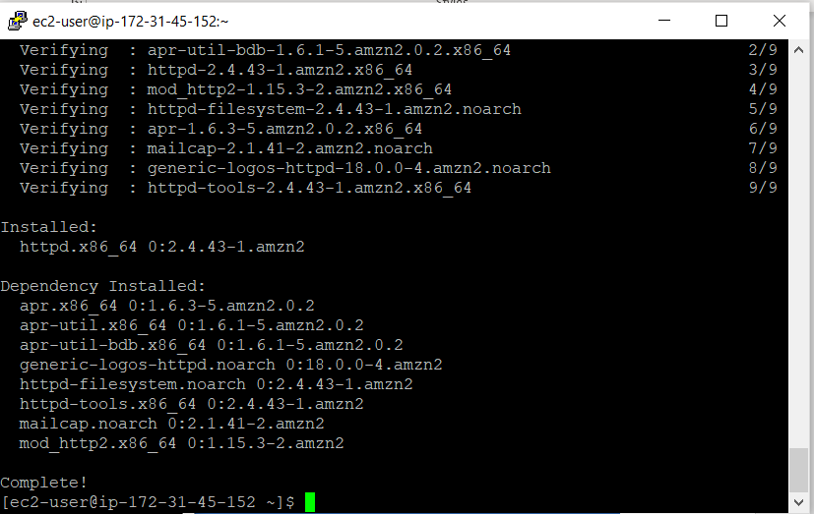

* Run the Public IP and see the output

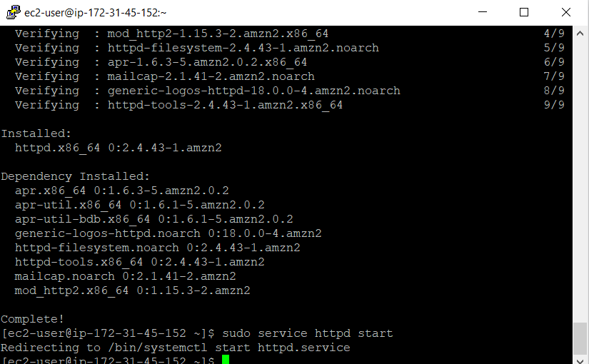

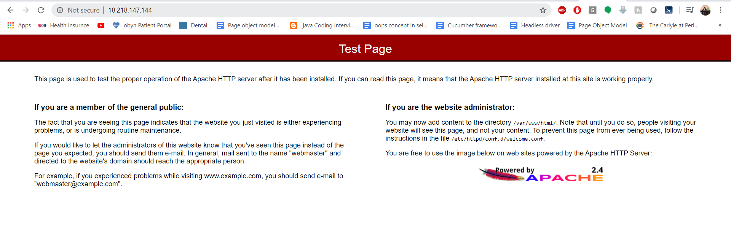

..

* Make sure to Configure the index.html with Custom data.

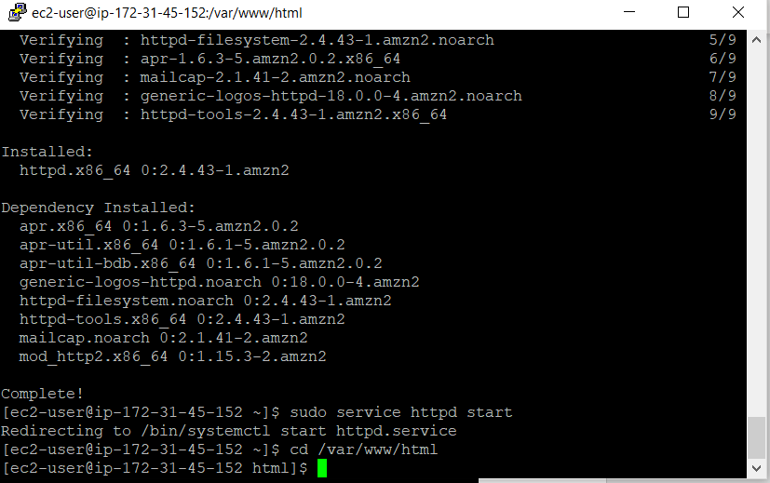

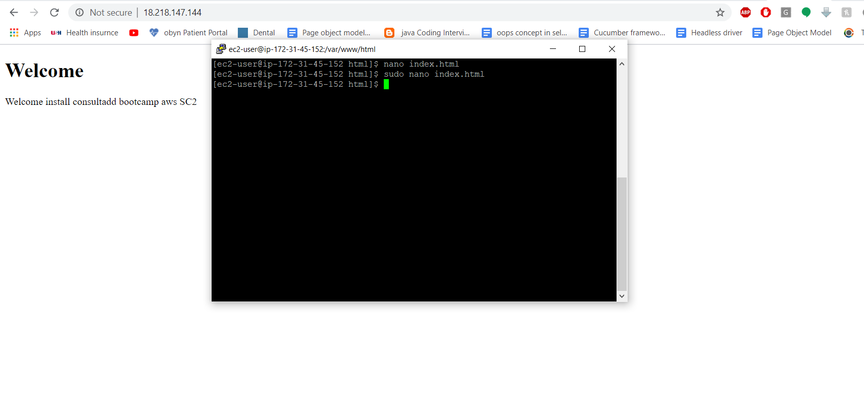

* Create three more files in the same directory /var/www/html/
  + Home.html
  + Payment.html
  + Login.html

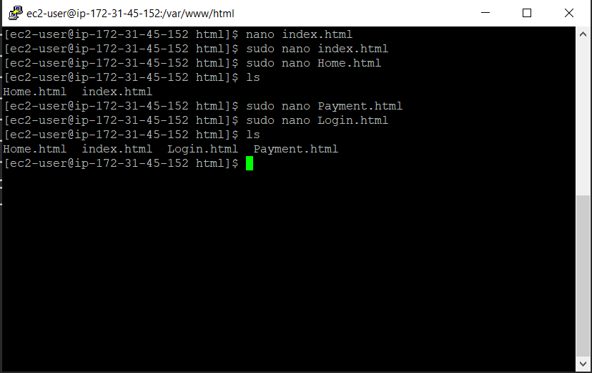

* Home.html Run all these pages from EC2 Public IP by Passing the URL.

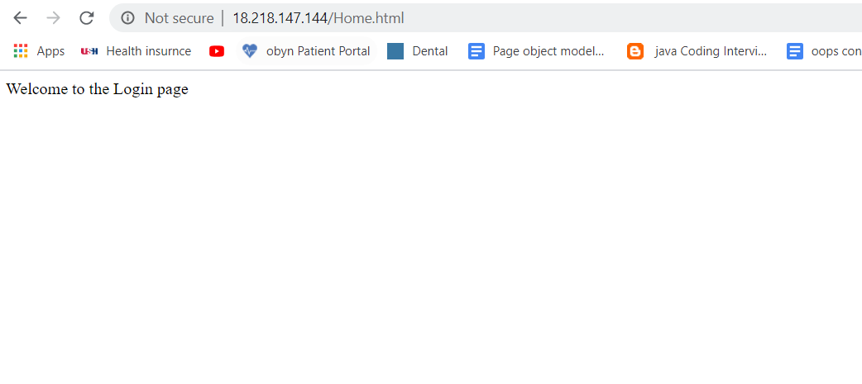

* + Payment.html

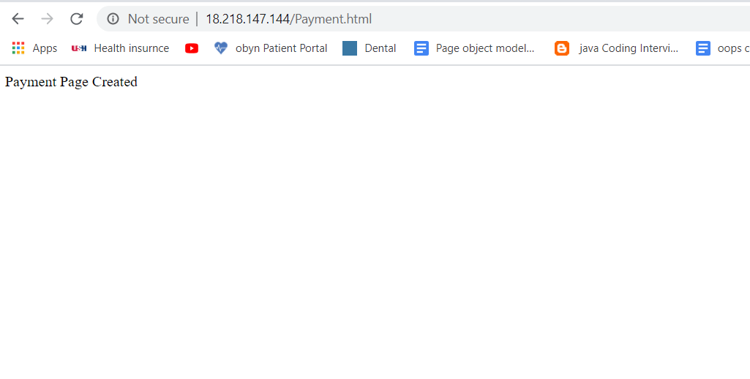

* + Login.html

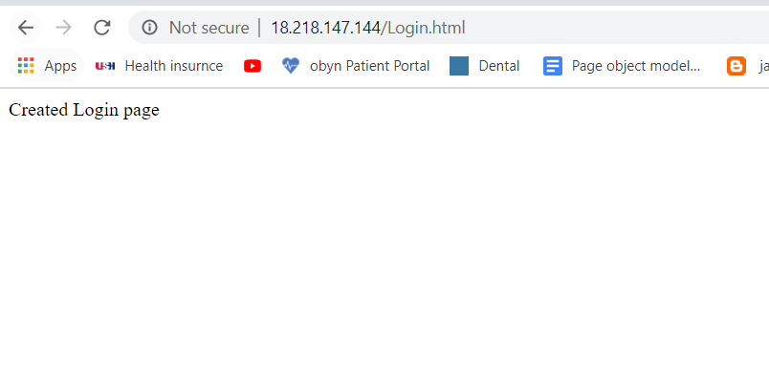

**TASK 04:**

* Install Git on EC2 and Clone all your repositories separately on EC2 in the folder called “repoonec2

sudo mkdir repoonec2

